**Executor of DOE John Robert Estate.**

DOE executor office,

In care of 23 Right Street, Deer park,

original state of Victoria,

Australasia.

[near 3023]

David Hurley man trading as the occupant of the office of Governor-General of the Commonwealth of Australia,

Government House,

Dunrossil Drive,

Yarralumla, Australian Capital Territory. [2600]

**Declaration of Peace**

**and the Surrendered Gift of Reversion of**

**Interest to the Commonwealth of Australia**

I am called by the name of John Robert which is the Christian name I was gifted by my parents. I am of the family of Doe.

I am a living man, born onto the landmass, my feet walk on the earth and I will return to the earth upon the death of my body.

My ancestry is Genesis 2:7 *And the LORD God formed man of the dust of the ground, and breathed into his nostrils the breath of life; and man became a living being.*

I am told that I was born from my mother’s living body on the 13th day of November in the year of the Lord nineteen hundred fifty two Anno Gomini within the walls of a building titled the Walter Credence Hosptial, Ragtree Burrow built on land in the Original State of Victoria.

**The Ancestry of Governance in the original States and the Commonwealth of Australia.**

[Psalms 22:28](http://www.kingjamesbibleonline.org/Psalms-22-28/) - *For the kingdom [is] the LORD'S: and he [is] the governor among the nations*.

With reference only to the countries coming under the authority of the England, Britain, Great Britain & United Kingdom’s King or Queen, this has been the Royal Arms of all English Monarchs since James I in 1603 to Her Most Excellent Majesty Queen Elizabeth the Second under the Crown of the United Kingdom with Her heir apparent being King Charles III.

 - 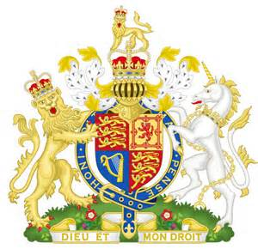

* The Lion *rampant* on the left-side is the emblem of the two-tribe of the House of Judah.
* The Unicorn *rampant* on the right-side is the emblem of the ten-tribes of the House of Israel, collectively make the 12-tribes of the Kingdom of Israel.
* The word British is Hebrew, meaning ‘the People of the Covenant.’
* The Supreme Crowned Lion *guardant* at the top of the emblem symbolizes Christ, the Rightful King of Israel.

Revelation 5:5 “And one of the elders saith unto me, Weep not; behold, the Lion of the tribe of Judah, the Root of David, hath prevailed to open the book, and to loose the seven seals thereof.”

James I authorised the 1611 King James Bible. *Cum Privilegio Regiae Maieftatis* His Coat of Arms, complete as above, is at the front of those Scriptures.

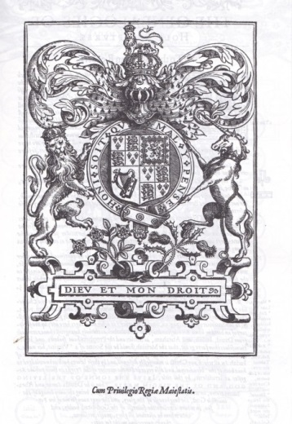

Her Most Excellent Majesty Queen Elizabeth the Second under the Crown of the United Kingdom, the current constitutional monarch, an heir to late Her Most Excellent Majesty Queen Victoria, is of the House of David, with Her heir apparent being King Charles III.

Description: General genealogy from 
Judah to Queen Elizabeth II

Psalm 89:3 God said: “I have made a covenant with my chosen, I have sworn unto David my servant, Thy seed will I establish for ever, and build up thy throne to all generations. Selah.”

Jeremiah 335-26 “Thus saith the LORD; If my covenant be not with day and night, and if I have not appointed the ordinances of heaven and earth; Then will I cast away the seed of Jacob, and David my servant, so that I will not take any of his seed to be rulers over the seed of Abraham, Isaac, and Jacob: for I will cause their captivity to return, and have mercy on them.”

Elizabeth Mountbatten of the House of Windsor (the Queen), with Her heir apparent being King Charles III (the King) swears allegiance to the Lord and the Laws of God.

The Coronation Oath is a legal contract between the Queen and Her heir apparent King Charles III with the allegiance of her people to uphold the Gospel of Christ, as Head of State in a Christian service of praise and worship.

After the Queen's anointing, she holds the sceptre and orb, a golden sphere surmounted by the cross, and with Her heir apparent being King Charles III its a reminder that the whole world is subject to Christ.

When Sovereign is presented with the Holy Bible at the Coronation Service these words are addressed to the Monarch:

Our gracious Sovereign: to keep your Majesty ever mindful; of the Law and the Gospel of Christ as the rule for the whole life and government of Christian Princes, we present you with this book, the most valuable thing that this world affords.

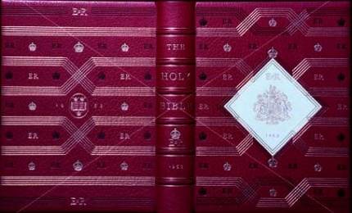

The cover of that Holy Bible was embossed with the Royal Arms of all English monarchs under covenant with the Christ, the Rightful King of Israel, who is the government. Jesus Christ is of the House of David.

Matthew 1:1 The book of the generation of Jesus Christ, the son of David, the son of Abraham.

Her Most Excellent Majesty Queen Elizabeth the Second under the Crown of the United Kingdom and with Her heir apparent being King Charles III then, sits on the throne of my inheritance as a new child in Christ. I can serve only one master and that is my God, but I am aware of the idealistic notion of government of Jesus Christ on the throne of David.

Isaiah 9: 6-7 For unto us a child is born, unto us a son is given: and the government shall be upon his shoulder: and his name shall be called Wonderful, Counsellor, The mighty God, The everlasting Father, The Prince of Peace. Of the increase of His government and peace there shall be no end, upon the throne of David, and upon his kingdom, to order it, and to establish it with judgment and with justice from henceforth-even forever. The zeal of the Lord of hosts will perform this.

Her Most Excellent Majesty Queen Elizabeth the Second under the Crown of the United Kingdom rules the living men and women in her kingdom, as the Defender of the Faith of the Commonwealth of Australia Constitution Act, through her coronation onto the Throne of David with Her heir apparent being King Charles III.

I am known by the name John Robert of the family Doe and I am in the body of a living man.

The Lord God Almighty is the God of the living.

Matthew 22: 32 I am the God of Abraham, and the God of Isaac, and the God of Jacob? God is not the God of the dead, but of the living.

Mark 12: 27 I am the God of Abraham, and the God of Isaac, and the God of Jacob? He is not the God of the dead, but the God of the living: ye therefore do greatly err.

Matthew 6:9-13

After this manner therefore pray ye:

Our Father which art in heaven,

Hallowed be thy name.

Thy kingdom come.

Thy will be done in earth, as *it* *is* in heaven.

Give us this day our daily bread.

And forgive us our debts, as we forgive our debtors.

And lead us not into temptation, but deliver us from evil:

For thine is the kingdom, and the power, and the glory, for ever.

Amen.

The Original State of Victoria

1. The colony was established 1st of July 1851, under the Royal Arms of George III, King of Great Britain and Ireland, is depicted here:



1. The Victoria Constitution was proclaimed on 23 November 1855, enabling and enacting responsible government under this Seal:

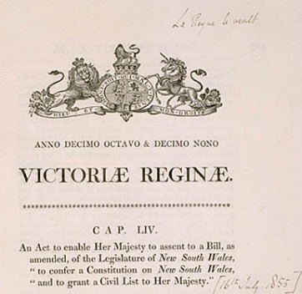

1. The colony of Victoria, joined the Federated Commonwealth of Australia and became an Original State, under the Commonwealth of Australia Constitution Act declared at 1st January 1901 which executes under this Seal:

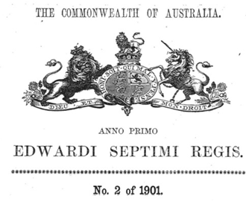

The Commonwealth of Australia

The Commonwealth of Australia is the body created and acknowledged in the following Statutory Instruments under Seal. It is and cannot be any other body under any other seal, without the express permission of those people documented in the Preamble to that Constitution:

1. The Royal Commission of Assent by the late Her Most Excellent Majesty Queen Victoria to Commonwealth of Australia Constitution 1900 (United Kingdom), dated 9th July 1900, as depicted here:

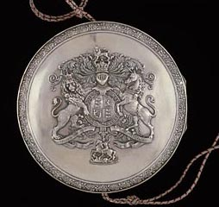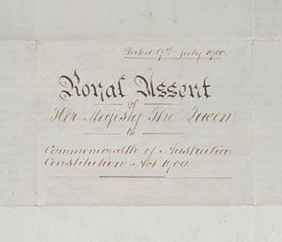

1. The Royal Coat of Arms on the Commonwealth of Australia Constitution Act 1900 (United Kingdom)[63 & 64 Vict] [Ch. 12.] is depicted here: :

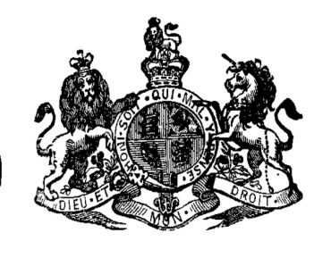

1. The Royal Coat of Arms on the Proclamation and Gazettal of the Commonwealth of Australia Constitution, dated 1st January 1901, by the Federal Parliament of the Commonwealth of Australia, created under the Constitution as the ‘company articles’ is depicted here:

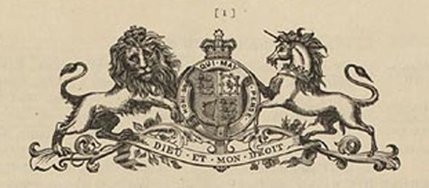

1. The Royal Coat of Arms on the Letters Patent for the Governor-General of the Commonwealth of Australia, as depicted here:

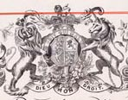

1. The Royal Coat of Arms of the Commonwealth of Australia over the front entrance for the Parliament of the Commonwealth of Australia, as depicted here:

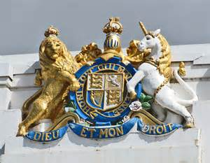

1. The Royal Coat of Arms by the late Her Most Excellent Majesty Queen Victoria, her heirs and assigns, binding the authority given in the compact known as the Commonwealth of Australia Constitution Act and given through the Letters Patent of the Governor-General to enable and execute any and all enactments of the Federal Parliament of the Commonwealth of Australia under, and to, the Commonwealth of Australia Constitution Act, as depicted here:

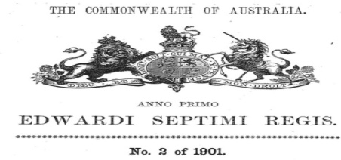

The people of the Original States and the Commonwealth of Australia

1. The people of each colony agree to be united under the indissoluble Federal Commonwealth of Australia and form a new State to be called the Commonwealth of Australia.

Preamble: Whereas the people of New South Wales, Victoria, South Australia, Queensland, and Tasmania, humbly relying on the blessing of Almighty God, have agreed to unite in one indissoluble Federal Commonwealth under the Crown of the United Kingdom of Great Britain and Irelands, and under the Constitution hereby established:

That agreement was created under this seal:



2. The previous Head of State of the Commonwealth of Australia was Her Most Excellent Majesty Queen Elizabeth the Second under the Crown of the United Kingdom who held the title in the Commonwealth as “Elizabeth the Second, by the Grace of God of the United Kingdom, Australia and Her other Realms and Territories Queen, Head of the Commonwealth, Defender of the Faith.” with Her heir apparent being King Charles III.

Full Faith and Credit between the Commonwealth of Australia and the Original States

Extract from the Commonwealth of Australia Constitutional Act [Ch 12. 63 & 64 Vict.]

Definitions: 6. ‘The States’ shall mean such of the colonies of New South Wales, New Zealand, Queensland, Tasmania, Victoria, Western Australia, and South Australia….may be admitted into or established by the Commonwealth as States; and each of such parts of the Commonwealth shall be called “a State”.

“Original States” shall mean such States as are parts of the Commonwealth at its establishment.

That agreement was created under this seal:

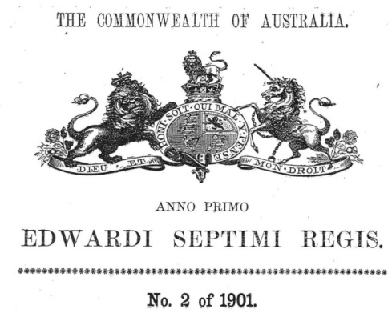

2. from the Commonwealth of Australia Constitutional Act [Ch 12. 63 & 64 Vict.]

106. The Constitution of each State of the Commonwealth shall, subject to this Constitution, continue as at the establishment of the Commonwealth, or as at the admission or establishment of the State, as the case may be, until altered in accordance with the Constitution of the State.

107. Every power of the Parliament of a Colony which has become or becomes a State, shall, unless it is by this Constitution exclusively vested in the Parliament of the Commonwealth or withdrawn from the Parliament of the State, continue as at the establishment of the Commonwealth, or as at the admission or establishment of the State, as the case may be.

108. Every law in force in a Colony which has become or becomes a State, and relating to any matter within the powers of the Parliament of the Commonwealth, shall, subject to this Constitution, continue in force in the State; and, until provision is made in that behalf by the Parliament of the Commonwealth, the Parliament of the State shall have such powers of alteration and of repeal in respect of any such law as the Parliament of the Colony had until the Colony became a State.

109. When a law of a State is inconsistent with a law of the Commonwealth, the latter shall prevail, and the former shall, to the extent of the inconsistency, be invalid.

Indissoluble

**Definition of Indissoluble:** Unable to be destroyed; That cannot be broken or rightfully violated; perpetually binding or obligatory;

**Covering Clause:** The provisions of this Act referring to the Queen shall extend to Her Majesty’s heirs and successors in the sovereignty of the United Kingdom.

#### Statute of Westminster Adoption Act 1942

8   Saving for Constitution Acts of Australia and New Zealand

Nothing in this Act shall be deemed to confer any power to repeal or alter the Constitution or the Constitution Act of the Commonwealth of Australia or the Constitution Act of the Dominion of New Zealand otherwise than in accordance with the law existing before the commencement of this Act.

#### Australia Act 1986

##### 5  Commonwealth Constitution, Constitution Act and Statute of Westminster not affected

                   Sections 2 and 3(2) above:

                     (a) are subject to the Commonwealth of Australia Constitution Act and to the Constitution of the Commonwealth; and

                     (b) do not operate so as to give any force or effect to a provision of an Act of the Parliament of a State that would repeal, amend or be repugnant to this Act, the Commonwealth of Australia Constitution Act, the Constitution of the Commonwealth or the Statute of Westminster 1931 as amended and in force from time to time.

Documentation

A***.*** I have in my possession a document which is entitled INFORMATION FORM FOR REGISTRATION OF BIRTHS/certificate of live birth/application for citizenship from the office of the Registrar of Births, Deaths and Marriages/home affairs, for which I provided ninety five dollars and thirty cents [$95.30] in functional Australian currency;

alongside the Victorian seal at the top of that document is No:12345.

This document has details on it that are statements by a living being called Jane Doe with the Maiden Surname of WHITE, and signed this document as J. Doe.

This living being has acknowledged they are the Mother.

The name on that document, that was written as given to the offspring being recorded, has the

Christian Names of the offspring as John Doe.

The front of this document states via stamp the following;

This is a true copy of the Original entry for the INFORMATION FORM FOR REGISTRATION OF BIRTHS/certificate of live birth/application for citizenship for the birth of John Robert Doe.

There is a signature at the bottom left side by Deerbon*,* Registrar.

That signature is followed by the seal of the Registry Births, Deaths & Marriages for the state of Victoria.

B.I have in my possession a document entitled BIRTH CERTIFICATE/CITIZENSHIP CERTIFICATE from the Registry of Births, Deaths and Marriages from the State of Victoria, for which I provided the forty-three dollars and eighty cents [$43.80] in functional Australian currency.

That document prints the CHILD’s name as

Family Name DOE

Given Name(s) John Robert

There are no signatures of my mother or father on this BIRTH CERTIFICATE/CITIZENSHIP CERTIFICATE document.

The BIRTH CERTIFICATE/CITIZENSHIP CERTIFICATE document has a signature and a stamped Seal from the Victoria Registry of Births, Deaths and Marriages/Home Affairts. The signature is that of T.J.RUDOLF REGISTRATION OFFICER.

In a box at the top right hand side of this BIRTH CERTIFICATE/CITIZENSHIP CERTIFICATE document is the registration identifier 12345/1962.

The reverse side of this BIRTH CERTIFICATE/CITIZENSHIP CERTIFICATE document has two (2) bar codes on it with the following numbers and symbols under them:

CLH - POS – 1234567 – 1 - 1 - (bottom left hand corner),

12345678901 - (bottom right hand corner).

and under the bar code and number (top left hand corner) the following

John Robert Doe

15 Smith Street

Brownsville NSW 2090

The Irrevocably Surrendered Gift

All parties are on Notice that any and all references to the Commonwealth of Australia in this document are referring only to the Commonwealth of Australia [CH.12.] [63 & 64 Vict.] Proclaimed and Gazetted 1st January 1901 and the Constitution created at that time; at no time does any reference herein relate to any governance structure that has been formed under the Australia Act 1986 and/or any legislation promulgated after the Statute of Westminster 1931 and its nexis to Statute of Westminster adoption Act 1942, other than as expressly referenced to demonstrate the obligation to strictly conform to the Commonwealth of Australia Constitution Act 1901.

The man and woman I know as my mother and father used the BIRTH CERTIFICATE/CITIZENSHIP CERTIFICATE document to establish my age qualifications to enter school, start a bank account, for medical concerns, as well as for other purposes that may have been requested.

At a later date I used the BIRTH CERTIFICATE document for other commercial and legal purposes.

I was not aware at those times that the BIRTH CERTIFICATE document was not in the name I am called, being the name my parents placed on the INFORMATION FORM FOR REGISTRATION OF BIRTHS/certificate of live birth/application for citizenship, but rather it was instead in the name of an entity found only on the BIRTH CERTIFICATE/CITIZENSHIP CERTIFICATE document. The names attached to the BIRTH CERTIFICATE/CITIZENSHIP CERTIFICATE document, which I did accept as my own under necessity, include variations of the personality of the name and/or military titles. I only recently became aware that the BIRTH CERTIFICATE/CITIZENSHIP CERTIFICATE document and the names that it represented were not mine to use without usufructory obligation unless and until I assigned the inherent reversionary interest associated with it to the dejure Commonwealth of Australia.

Consequent to, and reliant upon, the documented information herein I accept my inheritance as being of the people of the Original State of Victoria and of the people of the Commonwealth of Australia. I accept that inheritance as the man called John Robert of the family Doe.

I apologise for any errors or discord that I have created by being in ignorance of my inheritance and by using the Legal Title to enter commerce in the Exclusive Economic Zone, under a foreign jurisdiction without recognising that there was a usufructory obligation.

I authorise the Governor-General of the Commonwealth of Australia to act as the fiduciary trustee, to correct that error and organise the irrevocable surrender of the gift of reversionary Interest in the Estate in relation to the creation of the Record INFORMATION FORM FOR REGISTRATION OF BIRTHS/certificate of live birth/application for citizenship and the BIRTH CERTIFICATE/CITIZENSHIP CERTIFICATE document to the Commonwealth of Australia.

I am irrevocably gifting the mentioned reversionary interest to use for the purposes of the restoration, betterment, security, prosperity, enrichment and peace of the people of the Commonwealth of Australia (who are found in the Preamble to the Constitution Act), without any allocation being provided for any military styled philosophies and/or functions that causes, or which may have a nexus to cause, physical harm or financial harm or mental harm or hardship to any living soul.

I am irrevocably assigning the specific past, present and future reversionary interests, created in the Estate by the use of those titles, to the Commonwealth of Australia, in order to assist the Federal Parliament of the Commonwealth of Australia and/or the oringal States and/or Western Australia and/or the Northern Territory and/or the Australian Capital Territory in providing to the men and women of the Commonwealth of Australia, all just wants and needs and all rightful peace, order and good government, as documented at sections 51 and 52 of the Commonwealth of Australia Constitution, the document under that same Coat of Arms, Signed, Sealed, Proclaimed and Gazetted 1st January 1901, as the premier act of the indissoluble Federal Parliament of the Commonwealth of Australia.

I further request that this gift be used to create only good for the people of the Commonwealth of Australia, who are the people of the Original States and/or Western Australia and/or the Northern Territory and/or the Australian Capital Territory, and that no harm whatsoever shall arise from its use or be created by it against any living man or woman, today or in future.

In return I require:

* Innocent passage, and
* The security of person as a peaceful inhabitant of this land, and
* Safe harbour, and
* Quiet enjoyment, and
* The provision for my just wants and needs, and
* That all usufuctory obligations are discharged and settled by the party holding the reversionary interest and that any party bringing a liability immediately settle and discharge said liability with commensurate remedy and/or relief, and
* Land and/or house to reside in/on, and
* To retain and enjoy my right of choice to be anywhere, where I do not cause harm to others, without any hindrance to my safety and security, and
* To retain and enjoy, at my sole discretion, my right to refuse vaccinations, my right to refuse any medical device, my right to refuse any attempt of another to interfere with my deoxyribonucleic acid or ribonucleic acid and/or genes and/or chromosomes, my right to fluoride free water, my right to access to any and all natural therapies and or natural supplements, and
* To retain and enjoy my right to freedom and to freely move about and/or on the land, water or air, where it does not cause harm to others, without any hindrance and/or persecution, and
* To retain and enjoy my right to access and consume and to grow non-genetically modified foods and foods without any deleterious environmental pollutants, and
* To retain and enjoy my right to fresh, clean, unadulterated air, including but not limited to being exposed to pollutants of any kind, including but not limited to fallout from Chemtrails (geoengineering), industrial emissions, unnatural electromagnetic radiation or nuclear radiation or any un-necessarily burned fossil fuels, and
* To retain and enjoy my right to privacy without any hindrance and/or persecution, and
* To retain and enjoy my right to emotional freedom where it does not cause harm to others, and
* To retain and enjoy my right to live the life I choose, where it does not cause harm to others, without any ridicule, hindrance and/or persecution, and
* To retain and enjoy my right to think autonomously without any hindrance and/or persecution, and
* To retain and enjoy my right to spiritual freedom and to seek God/source on my own terms, and
* To retain and enjoy my power to exercise God/source given rights of free will, to my Estate, freedom, and personal liberty in my spiritual journey without impediment, and
* To be supported in my endeavor for a happy, healthy life.

Should I receive no correspondence within ten (10) days of the receipt of this communication, that inaction will be taken to constitute the irrevocable agreement of the parties under the terms stipulated and an estoppel will exist without futher Notice, under the doctrine of laches.

I shall remain neutral, doing God’s work in His peace.

Being of the age of majority and being competent, this is my will.

Declaration of Surrender of Reversionary Interest

I, the man called by the name of John-robert, am a creation, brought into being by Almighty God.

Therefore I honour My God, who is the Almighty God of the living, and who is seemingly referred to in the Coronation Oath, and through whom the Federal Parliament of the Commonwealth of Australia and the Parliament of the Original State of Victoria, governs in peace, welfare, order and good government.

1. Of my free will, I am irrevocably surrendering the gift of the INFORMATION FORM FOR REGISTRATION OF BIRTHS/certificate of live birth/application for citizenship to the Commonwealth of Australia.
2. Of my free will, I also provide the BIRTH CERTIFICATE/CITIZENSHIP CERTIFICATE E document to the Commonwealth of Australia, which I will also now continue to use without usufructory obligation.
3. I authorise that every commercial and financial element attached and/or emanating from and/or created by using the BIRTH CERTIFICATE/CITIZENSHIP CERTIFICATE TE document in any capacity whatsoever, including but not limited to all such financial instruments and securities, will be collected into the estate of John-robert of the family Doe.
4. I authorise that all futures shall be collected, ceased and obliterated and hereby give Notice that I will not act as surety for them, in any capacity, from this day forward.
5. I authorise that the entire total of the reversionary interest of these financial instruments, securities and futures, collected into my estate, shall be assigned over to the Treasury of the Commonwealth of Australia with those financial instruments, securities and futures being governed by the Commonwealth of Australia under a lawful Head of Power as defined in the Commonwealth of Australia Constitution Act for use Federally and by the Original States.
6. I authorise that the Treasury of the Commonwealth of Australia can collect the Interest so generated by the Estate within the corporate spehere, for and on behalf of the men and women of the nation, with respect the provisions stipulated in these documents.
7. I state that with myself as the Grantor/Beneficiary, I shall solely retain the naked ownership and all related rights such as the quiet enjoyment and/or use and/or disposal and/or modification and/or right to re-lease of that property, with any maintenance/upkeep, taxes, inventories, bonds and claims settled and/or discharged by the usufructory.
8. The Commonwealth of Australia may use that gift as it sees fit, while remaining in compliance with the expressed stipulations, in order to ensure the peace, security and prosperity of the living men and women of the Commonwealth of Australia and in order that the indissoluble Federal Parliament of the Commonwealth of Australia and/or the oringal States and/or Western Australia and/or the Northern Territory and/or the Australian Capital Territory may continue to govern in peace, order and good government.
9. I authorise the Parliament of the Commonwealth of Australia to seek the assistance of the nations under the Law of Nations in order to protect this gift particularly, but not limited to, under the Head of Power section 119 of the Commonwealth of Australia Constitution Act which states: The Commonwealth shall protect every State against invasion and, on the application of the Executive Government of every State, against domestic violence*.*
10. In relation to the legal title being the name on the Birth Certificate/Cizitenship Certificate, I surrender and assign any and all reversionary interest to the Commonwealth of Australia (as clearly described above) for quittance, discharge, settlement, and closure.
11. I assume no liability and do not consent to continue to stand as surety for any name or title connected to those documents and I give the full faith and credit of those titles to the Commonwealth of Australia as described above.

In deference to Almighty God my Creator, I use my freewill and intent as provided by My Father, through faith, belief, and service to Him and through His Son, Jesus Christ

Matthew 6:20-21 But lay up for yourselves treasures in heaven, where neither moth nor rust doth corrupt, and where thieves do not break through nor steal: For where your treasure is, there will your heart be also.

Also Matthew 19:29; Mark 10:21; Luke 12:15

Matthew 22:21 ….Then saith he unto them, Render therefore unto Cæsar the things which are Cæsar’s; and unto God the things that are God’s.

Also Mark 12:17; Luke 20:25

It is my intention to remain in honour and peace for the rest of my days –

1. That I will love the Lord My God and His Son Jesus Christ. And that I will love my neighbour as myself.

Matthew 22:36–40 Master, which *is* the great commandment in the law? Jesus said unto him, Thou shalt love the Lord thy God with all thy heart, and with all thy soul, and with all thy mind. This is the first and great commandment. And the second *is* like unto it, Thou shalt love thy neighbour as thyself. On these two commandments hang all the law and the prophets.

Also Mark 12:28032; Luke 10:26-28; John 13:34-35

1. That I have forgiven all men/women their lawful and/or equitable trespasses against me, and that I not judge any man/women.

Matthew 6:14-15 For if ye forgive men their trespasses, your heavenly Father will also forgive you: But if ye forgive not men their trespasses, neither will your Father forgive your trespasses.

Also Mark 11:25

Luke 6:37 Judge not, and ye shall not be judged: condemn not, and ye shall not be condemned: forgive, and ye shall be forgiven:.

1. That I will turn my cheek and do good and be merciful to all men/women for all lawful and/or equitable transgressions.

Luke 6: 27-36  But I say unto you which hear, Love your enemies, do good to them which hate you, Bless them that curse you, and pray for them which despitefully use you. And unto him that smiteth thee on the *one* cheek offer also the other; and him that taketh away thy cloke forbid not *to* *take* *thy* coat also. Give to every man that asketh of thee; and of him that taketh away thy goods ask *them* not again. And as ye would that men should do to you, do ye also to them likewise. For if ye love them which love you, what thank have ye? for sinners also love those that love them. And if ye do good to them which do good to you, what thank have ye? for sinners also do even the same. And if ye lend *to* *them* of whom ye hope to receive, what thank have ye? for sinners also lend to sinners, to receive as much again. But love ye your enemies, and do good, and lend, hoping for nothing again; and your reward shall be great, and ye shall be the children of the Highest: for he is kind unto the unthankful and *to* the evil. Be ye therefore merciful, as your Father also is merciful.

1. I do not serve two masters and no man or woman stands between me and my God.

Matthew 6:24 No man can serve two masters: for either he will hate the one, and love the other; or else he will hold to the one, and despise the other. Ye cannot serve God and mammon.

**My Personal Claim**

I claim the peace of Jesus Christ a Son, of Almighty God, the Father and of the Holy Spirit.

John 14:27 Peace I leave with you, my peace I give unto you: not as the world giveth, give I unto you. Let not your heart be troubled, neither let it be afraid.

I claim the Queen’s Peace, wherein I “do right to all manner of people after the laws and usages of the realm without fear or favour, affection or ill-will” and that same is returned to me.

I ask for innocent passage and the security of myself as a man who is a peaceful inhabitant of this land.

I ask for safe harbour and the quiet enjoyment of my days as a sojourner on the land.

I will take a stand as a neutral living man labouring only in and for the glory of Almighty God, as He requests.

I shall remain neutral, doing God’s work in all peace.

I am acting and executing in peace, with all good intent for the full faith and credit of the people of the Commonwealth of Australia, who are the people of the Original State of Victoria.

Please retain this document in the files for yourself and any and all future holders of the office of Governor-General of the indissoluble Commonwealth of Australia.

**Conclusion**

In 1861, the late Her Most Excellent Majesty Queen Victoria issued a public declaration of neutrality. I will repeat her words, as they have standing and will assist to guide my attitude toward a peaceful future as a neutral man sojourning on the landmass of Australia, until my body returns to the dust and my spirit returns to My Father’s home:

“And we do hereby declare that all our subjects and persons entitled to our protection who may misconduct themselves in the premises will do so at their peril and of their own wrong, and that they will in no-wise obtain any protection from us against any liability or penal consequences, but will, on the contrary, incur our high displeasure by such misconduct.”

“And we do hereby further warn all our loving subjects, and all persons whatsoever entitled to our protection, that if any of them shall presume, in contempt of this Royal Proclamation, and of our high displeasure, to do any acts in derogation of their duty as subjects of a neutral sovereign, in the said contest, or in violation or contravention of the law of nations …….all persons so offending will incur and be liable to the several penalties and penal consequences by the said statute, or by the law of nations, in that behalf imposed or denounced.”

I trust that you understand,

[10th October, 2021]



**Signed by my hand:** John-robert of the family Doe.

Enclosed:

The INFORMATION FORM FOR REGISTRATION OF BIRTHS/application for citizenship of John-robert.

The BIRTH CERTIFICATE/citizenship certificate document of John Robert DOE.