**For those NATURALISED as AUSTRALIAN (or if your parents were naturalised and you were under the age of 16 years at the time) then an email needs to be sent to the Freedom of Information Section, Department of Home Affairs. Email:** [**foi@homeaffairs.gov.au**](mailto:foi@homeaffairs.gov.au)

**In the same way as the Certificate of Live Birth/Information Form For Registration Of Births/etc is the precursor document to the creation of the artificial Birth Certificate PERSON, the application for citizenship is the precursor document to the creation of the artificial Citizenship PERSON.**

**You will need to ensure that you have provided scanned photocopies (certified as copies by a Justice of the Peace) of your proof of identity attached to your email request.**

Proof of Identity documents may vary from State to State, but are likely to be similar to the following:

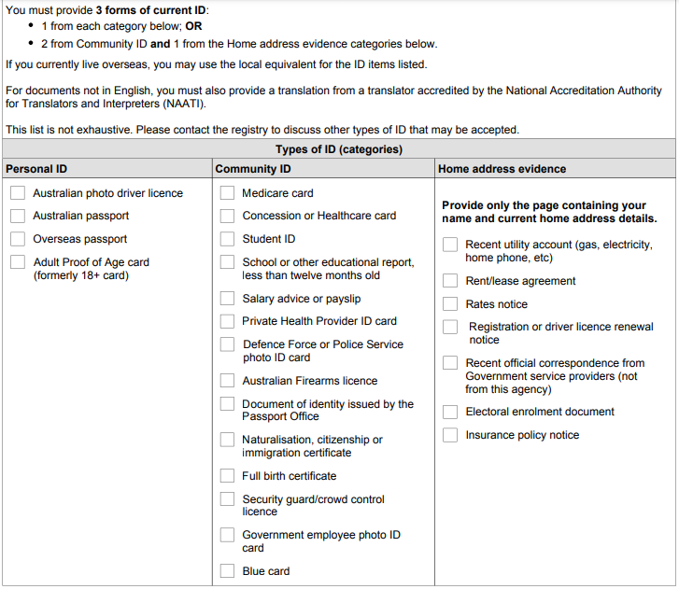

**Make a point to change anything in red to suit your circumstances, obviously then changing that colour back to black before sending:**

To whom it may concern,

This email request is an application for the purposes of the Freedom of Information Act.

My name is John Robert Doe and I was born on the 1st January, 1978 and I would like to obtain a certified copy of my application for citizenship please.

The ID number of the citizenship certificate is 01234567890 and I have attached a scan of documents which verify my identify.

**Please ensure to send a CERTIFIED COPY to**:

12 Kingcobra Drive,

Lucinda Hills,

Brisbane, Queensland, 4388

Thank you for your help, and if you require any further information please write back to this email address youremailaddress@hotmail.com

I trust that you understand,

Jon Robert Doe.

**They may respond and ask you the purpose of why you want the document, please reply in answer: “my own private use”**

**Please ensure when you receive your electronic paperwork from them as an attachment with their reply that it is a certified copy, meaning:**

“The certifier will:

1. examine the original to ensure it is not a copy or forgery
2. examine the copy to ensure it is identical to the original. A copy can be considered identical even if it is a different size or colour, so long as that does not result in the loss of any material information.

The certifier will then write or stamp the copy with the words: “Certified to be a true copy of the original seen by me.” They will sign and date the copy, and write or stamp their:

1. name
2. personal or professional address, and
3. qualification as an authorised certifier.”

There is a reality that I have not had the oppportunity to be able to demonstrate as yet, in relation to when the parents have become Naturlised, and have made the effort to include their children in the application who were under the age of 16 years at the time. I strongly suspect that if you are in this category that you would still be able to access that “application for citizenship” of your parents under freedom of information rules, as long as you demonstrate from your identification documents that you are the same individual as the person named in that application.

So, that would require an aleration to your request being something like the following:

To whom it may concern,

This email request is an application for the purposes of the Freedom of Information Act.

My name is John Robert Doe and I was born on the 1st January, 1978 and I would like to obtain a certified copy of my parents application for citizenship please. I was under the age of 16 years at the time of the application and I believe that my details were included in the application.

The ID number of the citizenship certificate is 01234567890 and I have attached a scan of documents which verify my identify.

**Please ensure to send a CERTIFIED COPY to**:

12 Kingcobra Drive,

Lucinda Hills,

Brisbane, Queensland, 4388

Thank you for your help, and if you require any further information please write back to this email address youremailaddress@hotmail.com

I trust that you understand,

Jon Robert Doe.