USUFRUCT  
(Arts. 562-612)

**Usufruct is a real right by virtue of which a person is given the right to enjoy the property of another with the obligations of preserving its form and substane unless the title constituting it or law provides otherwise**. (Q1, 1995 Bar) **Money may be the object of usufruct**. Abnormal usufruct are those where the usufructuary does not have the obligation of preserving the form and substance of the property which is the object of the usufruct.

A usufruct may be constituted:

1. By law.  
2. By the will of private persons expressed in acts inter vivos.  
3. By the will of private persons in a last will and testament.  
4. By prescription.

Distinction:

Usufruct                                                                        Lease  
1. Always a real right.                                                1. Becomes a real right only when registered.  
2. Person constituting it is the owner.                         2. Need not be the owner.  
3. Usufructuary is responsible for ordinary repairs.    3. Lessee is not.  
4. Usufructuary is responsible for taxes on the fruits. 4. Lessee in not.

As a rule, the usufructuary shall be entitled to all the natural, industrial and civil fruits of the party in usufruct. (Art. 566) With respect to hidden treasure which may be found on the property, he shall be considered a stranger.

Caucion juratoria is a case whereby the usufructuary, being unable to file the required bond or security, makes a “promise under oath” to take good care of the property (i.e., house and furniture) necessary for himself and his family and to return the same at the end of the usufruct. This can be applied to the instruments or tools necessary for an industry or vocation.

Obligations of the usufructuary during the pendency of the usufruct, among others:

1. To make ordinary repairs on the property.

2. To take care of the property as a good father of a family.

3. To pay the annual charges and taxes and those considered as a lien on the fruits. However, the taxes which, during the usufruct, may be imposed directly on the capital, shall be at the expense of the owner. (Art. 597)

4. To pay the expenses, costs and liabilities in suits with regard to the usufruct.

The usufructuary shall have the right to demand reimbursement from the owner of all necessary expenses which he might have incurred for the preservation of the property. This right, however, is not available to him with regard to useful and ornamental expenses, but he may remove the improvement provided that it is possible to do so without damage to the property. (See Art. 579) The usufructuary may set off the improvements he may have on the property against any damage to the same. (Art. 580) (Q7, 1996 Bar)

<https://attyrcd.wordpress.com/2014/04/01/property/>

We exist under the jurisdiction of natural law, but we can give up or contract away under substance redeemable money some of those rights to live under de jure consitution of 1901, but we can give up or agree away under fiat currency some of those rights to live under the corporate de facto constitution post 1933ish, with each jurisdiction being reliant as a subgroup on its outer circles of jurisdiction.

Untder the de jure constitution, which fervently protects our right to contract away from it into the de facto, we have a true right of privacy. Privacy on our land, privacy with our doctors, privacy with our lawyers ectera. We used to pay those individuals with substance redeemable currency, with that substance created by God. In that system the money was simply seen as fungbile to substance.

We still have those rights today, but we lose them immediately upon the use of fiat/kings currency, because when you use a currency that is without substance redeemability and can sipmly be hypothecated into existence, then whoever creates the currency becomes a (usually) silent third party to the agreement. In that instance we would be using the fiat currency of another to benefit ourselves, leaving us in a usufructory relationship, for which we hold obligations.

This is the cause of the loss of privacy rights on our land, and with our supposedly fiduciary obligated lawyers and their first loyalty to the court and with what is to come in relation to the privacy of our health/doctor relationship.

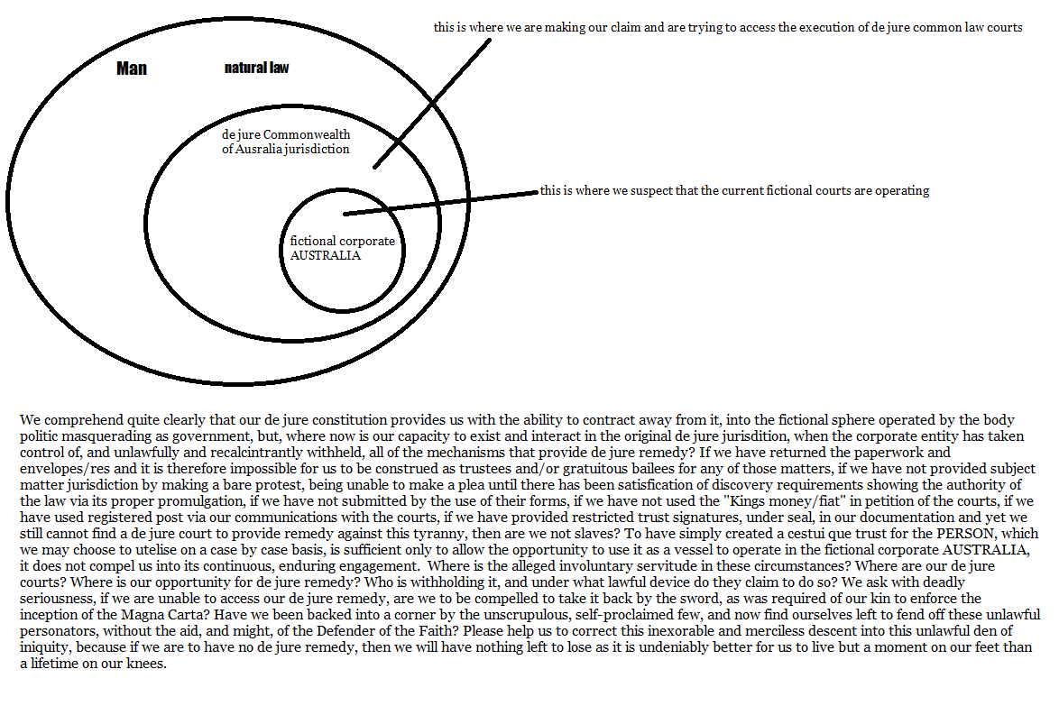



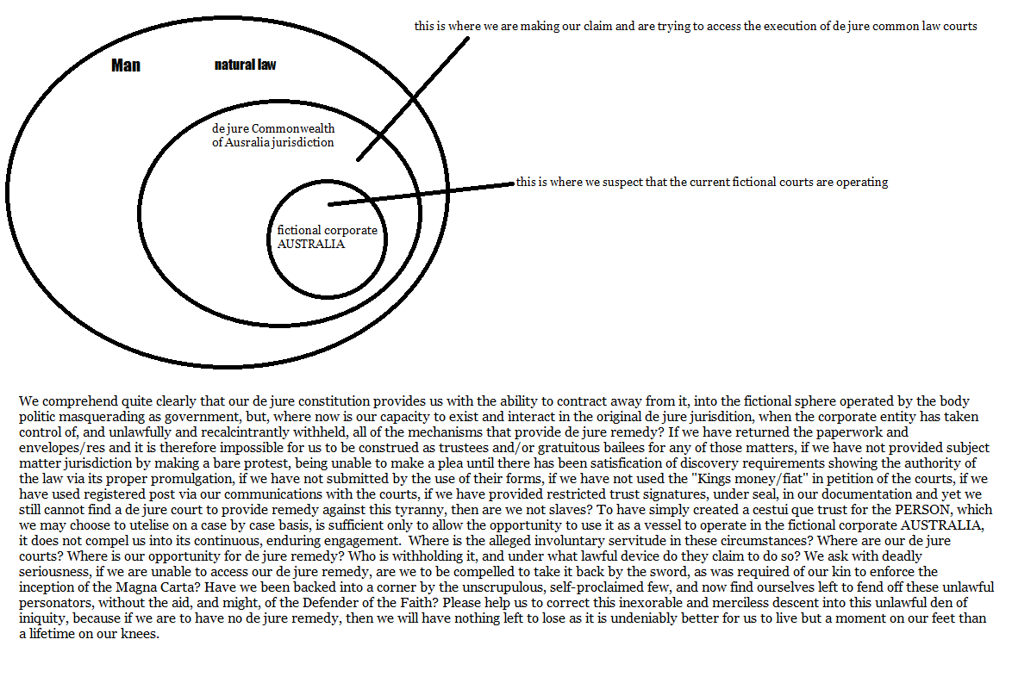

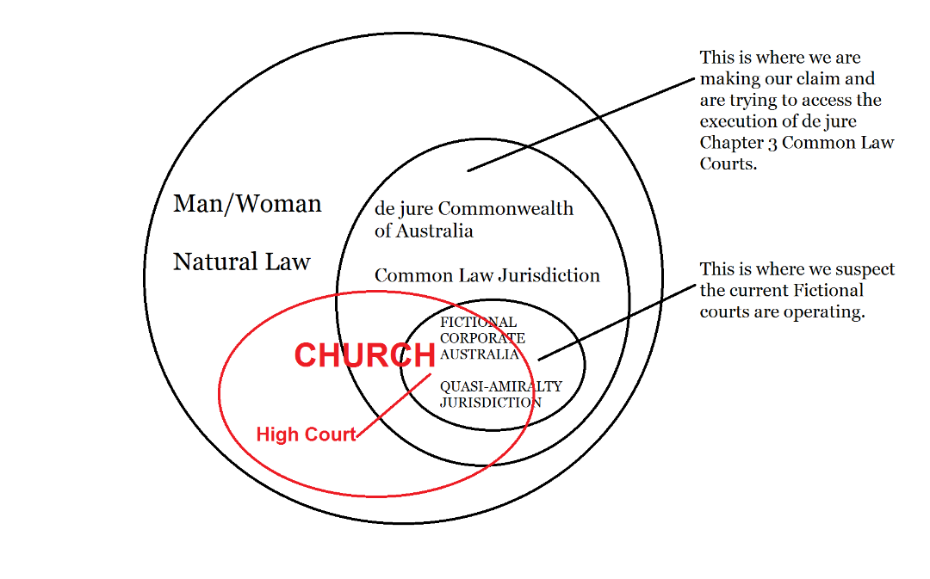



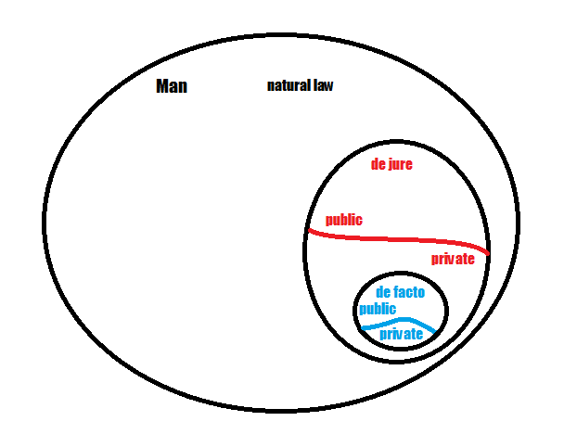



When we submit registrations, we are asking the corporate body politic to please do something for us. We ask them to break porperty that was otherwise owned in alloidum in the outer two cirlces of jurisdiction under natural law and the 1901 de jure constitution, into legal and equitable title.

This is done because since 1933 ish, pretty much the whole planet has only had a currency that was not redeemable, which caused a problem because contracts only exist when they are paid (not when they are made), which meant that we could no longer contract with fiat, but would instead only make agreements from then on, with a trust (which does not require substance as Res) rushing in to fill the void.

We can still exist in either of those two outside circles of jurisdiction however, and could still contract substance for substance, like “I will mow your lawn if you wash my car”.

Each and every time we submit an application (which bifurcates title), usually for a license that allows us to do for a fee in their jurisdiction for what we could have done for nothing in one of the outer jurisdictions, we are creating a discretionary trust where we usually end up in the presumed trustee position. The first time we encounter it is when our parents filled in an application for a birth certificate (certificate of live birth or birth registration statement) and the corporate body politic readily created one, and even threatens there would be a deleterious consequence if the birth was not registered.

Then we went around using it everywhere to submit applications, thereby voluntarily and intentionally (possibly not knowingly but ignorance is little excuse) joining and bonding ourselves to the artificial person as surety for it.

Most of this is due to our refusal or failure to restrict our liability to consequence via the use of our signature. We can largely keep ourselves diverse from the artificial person by signing “by accomodation” for it and given that we are dealing with trusts everywhere, it is also sometimes prudent to Notice the restriction of the role in the trust that one retains.

When we hold someone elses property, we are presumed as trustee and/or gratuitous bailee of that property, or possibly a thief. When we get a summons it says to turn up at a certain date, at a certain time for some shennanigans. We continue to hold the summons and must attend or else be compelled to attend as recalcitrant trustee to perform on the expression of the trust. IF we return that summons to them as its true owner, which is the obligation of a gratuitous baille, then the court do order an immediate adjournment, to allow them to try to serve it again.

anything we own that has relation to the use of a birth certificate means that we have gained by the use of property owned by another, ie a usufruct. We did not create the cestui que trust, they are the Creator or it, and the creator controls the created. They have not spent the funds within that cestui que, they have only managed it via securitisation and been compensated by the proceeds. If they had done it to then pass those proceeds back to treasury, then we would have no problem, as the treasury should use it to pay down the coporate national debt, but the courts/judges ectera instead leave it to sit for a while until it becomes abandoned funds and then they claim salvage rights against it.

And so therein the problem lies, obviously with all of the corrupt gatekeepers who are working only for self, but most importantly with our own failure. Sure, we where never explicitly told by the corporate artifice that the stuff in the cestui que trust was ours, for instance we just had to die and they would happily recongise it as such. Obviously there are many ways to terminate a trust relationship, and when we do, if there is a remainderment, it must go somewhere so that it does not unjustly enrich. This potential for us to get that remainderment is called ones “reversionary interest”.

The reason we can get to it is that “the certificate of live birth application for a birth certificate” is in our name, and when we hold a certified authenticated copy we are indisputably holder in due course of the equitable title to that, and possilby other trusts. Merge it with the legal title birth certificate and express it, or terminate it, or move it, whatever, it is up to you. Whilst our parents were originally the Grantor, we effectively “become the sole contributing beneficiary/Grantor” and the Grantor picks the Settlor, and the intent of the settlor is the law of the trust, and he picks who has what role ectera, so we take on the role of Settlor like that.

IF, we turn around and say, “hey look, we will give the de jure constitutional treasury the right to any gains from the birth certificate or its securitisation” then they have an obligation to provide consideration in kind, like just wants and needs, safe harbour, safe travel ectera. That leaves them in the usufructory position and leaves us back as naked owners with the right to sell, lease, modify, destory.

So at that point, if we again get attacked by the corporate body politic, then the de jure constitution positions kick in and they pull up, or more appropriately they understand the danger and flee. It should also mean that we are protected by the royal army, navy and airforce. So all our bills paid, our assets back owned by us, all upkeep taken care of, then we work simply to get enough cash to facilitate exchange between individuals; that is the construct of this elaborate system of saint germain.

When the rothschilds/morgans/de beers crew decided to start printing money for governments they wanted a surety to bond the coin, first the government put up the land as surety, and seventy years later that land was foreclosed on.

When you print 100 bucks, and you say I just want 1% of whatever I print in return for my efforts, then the next year, even if it were possible to collects the entire money supply of $100, then you would still owe the 1% x $100 component, requiring them to print that extra dollar, with the gap getting larger with every passing year, meaning its actually mathematical impossibile not go bankrupt; the dice were loaded.

then they asked the governments to put up the mined gold against that new borrowing, then seventy years later back in 1929 in Australia they confiscated everyones private gold hoardings under the no 31, commonwealth bank act:

http://classic.austlii.edu.au/au/legis/cth/num_act/cba1929311929202/

then they asked the governments to put up the last thing of substance that they had not yet directly stolen, and that was for the life force of the men and women of the planet, to which governments readily agreed. The world bank would ‘lend’ the country money based on population growth, if it were a newly born supposedly actuaries took into account its weight (in gold) and multiplied it by three score and ten for the likely age, and considered what your parents did for a living, then they took into account our Estate (% share in nations land and natural wealth).

They have since lost the opportunity to fully foreclose on those sureties as at the third succession of 70 years in bankruptcy there is some sort of (mosaic law?) forgiveness.

That money is sustance backed, just not substance redeemable. We underwrite it with our projected future efforts and share in the nations natural wealth when we engage with the corporate system and in return the system should be providing for all of our just wants and needs, in the style of the United States Public Law: “Chap. 48, 48 Stat. 112” under HJR 192 with the discharge all of our debts, public and private, dollar for dollar and for when they suspended the gold standard Public Law 73-10, 48 Stat. 112, 113 (1933)

That money is borrowed against us, and printed and loaned by the IMF to the corporate body politics masquerading as governments, for them to pay down with the provision for our just wants and needs as compensation. That allows those governments to pay down their corporate national debt, which is owed largely to us, the people because its borrowed into existence against us as surety.

To be clear, what most people cannot fathom is that the worlds fiat currencies are a cross breed that can be used to settle private debts as money of exchange between men and women and to discharge “quasi-public” debts as money of account when the administration cost of the debt would exceed the value of the debt and this construct of Lawful money is backed up in legislation at §16 of the Federal Reserve Act (1913) and its current codification in the United States Code at Title 12 USC §411 – They shall be redeemed in lawful money on demand.

Technically, as a man or woman, if we pay for any corporate ‘statement of account’ with cash, we should be able to get the tax office on behalf of treasury to compensate us in cash in exchange for the cash receipts. This is reliant on the fact that we can choose which jurisdiction we want to contract/agree to in any given moment, other than being restrained by previous contracts/agreements.

As a possibly important aside, the de jure Courts don’t get used much anymore, because it is more profitable not to and there isn’t much need to, unless the corporate courts themselves are looking for enforcement. Even since the time of Benion, a cleaner might put on a dress and a wig and sit atop the court, and if the parties should make a plea, then they would be bound by the jurisdiction of his decision.

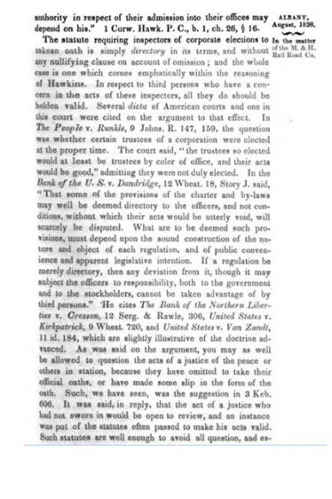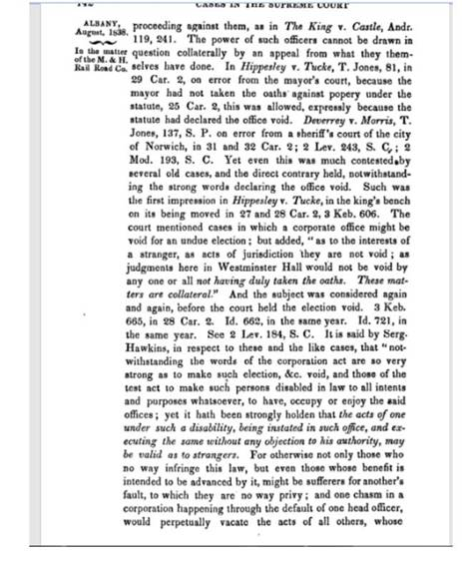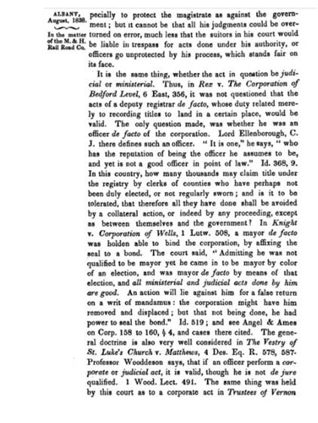

There is also a layer of war/state of emergency/marshal law that has been used, mainly with us all being consdiered trading with the enemy whenever we needed to buy things, but more lately with corona. We need to be in peace as a non-combatant, and in conformity with the lieber code, with the corporate body politic reputedly being here to help restore the peace. IF currencies go substance backed again now, the problem is that the self proclaimed elite have already printed free money and bought all the substance, so they win BIG time. IF we all took back control of the cetui ques and gave it over to a de jure, then the self-proclaimed elite would lose strength by us taking back control of those assets, BUT then any nanny state will eventually become corrupt again.

We need some way to be able to tell when people are lying. Like a pair of glasses, or a virus in some computer software, that when we see people talking its tell us as much, then we could test it on ourselves and friends and take great notice of it whenever “the establishment is talking”.

In the following cases the owner of a movable who has lost it or who has been unduly deprived thereof can no longer recover it from the possessor:

1. If recovery is no longer possible because of prescription. (Art. 1132)  
2. If the possessor had acquired the thing from a person whose authority to sell, the owner is by his conduct precluded from denying. (Art. 1505)  
3. If the possessor has acquired the thing from a merchant’s store, or in fairs, or markets.  
4. If the possessor is now the owner of the thing in accordance with the principle of finders keepers.

(Art. 719)

Article 562 - 578

1. Define usufruct.

**Usufruct is a real right by virtue of which a person is given the right to enjoy the property of another with the obligation of preserving its form and substance**, unless the title constituting it or the law provides otherwise.

2. What are the three fundamental Rights Appertaining to Ownership?

**Ownership consists of three fundamental rights**, to wit**:**

**jus disponende (right to dispose)**

**jus utendi (right to use)**

**jus fruendi (right to the fruits)**

3. Of the above-mentioned fundamental rights, what consists usufruct and naked ownership?

**The combination of the jus utendi and jus fruendi is called usufruct. The remaining right jus disponendi is really the essence of what is termed "naked ownership".**

4. What right is transferred to the usufructuary and what right is remained with the owner?

In a usufruct, only the jus utendi and jus fruendi over the property is transferred to the usufructuary. The owner of the property maintains the jus disponendi or the power to alienate, encumber, transform, and even destroy the same. (Hemedes vs. CA, 316 SCRA 347 1999).

5. What are the formulae with respect to full ownership, usufruct, and naked ownership?

The following are the formulae:

**Full Ownership equals Naked Ownership plus Usufruct**

Naked Ownership equals Full Ownership minus Usufruct

Usufruct equals Full Ownership minus Naked Ownership

6. **What are the characteristics** or elements **of usufruct**?

The following are the characteristics or elements of usufruct:

ESSENTIAL CHARACTERISTICS: those without which it can not be termed

usufruct:

(a) **It is REAL RIGHT (whether registered in the Registry of Property or not).**

(b**) It is of a TEMPORARY NATURE OR DURATION (not perpetual**, otherwise it becomes emphyteusis). Its purpose is to enjoy the benefits and derive all advantages from the object as a consequence of normal use or Exploitation.

NATURAL CHARACTERISTIC OR ELEMENT: that which ordinarily is present, but a contrary stipulation can eliminate it because it is not essential. The obligation of CONSERVING or PRESERVING the FORM AND SUBSTANCE (value) of the thing. Example- a swimming pool must be conserved as a swimming pool.

ACCIDENTAL CHARACTERISTIC or ELEMENTS: those which may be present

or absent depending upon the stipulation of the parties.

Examples:

whether it be a pure or a conditional usufruct;

the number of years it will exist;

whether it is in favor of one person or several, etc.

7. **What are the requisites of usufruct?**

**There are two requisites of usufruct- the essential and the accidental. The essential requisite is the right to enjoy the property of another, while the accidental requisite is the obligation of preserving the form and substance of such property. The latter is accidental because the title constituting the usufruct or the law may otherwise provide, as in the case of abnormal usufructs.**

8. What are the REASONS for conserving form and substance?

The following are the reasons for conserving form and substance:

to prevent extraordinary exploitation;

to prevent abuse, which is frequent;

to prevent impairment.

9. What may be the object of usufruct?

**The following may be the object of usufruct:**

**(a) May be real or personal property. Thus, there can be a usufruct over an automobile or over money.**

**(b) May be sterile or productive (fruitful things). Thus, there can be a usufruct over sterile animals.**

**(c) May be created over a right (as long as it is not strictly personal or intransmissible, and as long as it has an independent existence. Thus, there**

**can be no usufruct over an easement, for the latter has no independent existence.**

15. How may usufruct be constituted?

**A usufruct may be constituted:**

**by law;**

**by the will of private persons expressed in acts inter vivos;**

**by the will of the private persons expressed in a last will and testament; and**

**by prescription.**

16. How may a usufruct be classified as to origin?

Usufruct may be classified into the following manner as to origin:

LEGAL (created by law)

Example: Usufruct of parents over the property of their unemencipated

children. Such usufruct cannot, because of family reasons, be mortgaged or

alienated by the parents.

VOLUNTARY OR CONVENTIONAL

Created by will of the parties INTER VIVOS. (as by contract or donation) Example: when an owner sells or alienates the usufruct. Or created MORTIS CAUSA (as in last will and testament).

MIXED OR PRESCRIPTIVE

Created by both law and act of a person.

Example: I possessed in good faith a parcel of land which really

belonged to another. Still in good faith, I gave in my will to X, the naked ownership of the land and to Y, the usufruct. In due time, Y may acquire the ownership of the usufruct by acquisitive prescription.

17. **Is it a must that the usufruct over real property be registered?**

**Yes. A usufruct over real property, being a real right, must be duly registered in order to bind innocent third parties.**

22. **What are the rules governing a usufruct**?

The following are the rules governing a usufruct:

**FIRST, the agreement of the parties or the title giving the usufruct (thus, by agreement, the usufructuary may be allowed to alienate the very thing held in usufruct although generally, this alienation is not allowed by the codal provisions).**

**SECOND, in case of deficiency, apply the Civil Code**.

23. In case of conflict, what rule is applicable?

In case of conflict between the rights granted a usufructuary by virtue of a will, and codal provisions, the former, unless repugnant to the mandatory provisions of the Civil Code, should prevail.

24. Who owned the naked ownership of properties endowed to a chaplaincy?

The naked ownership of properties endowed to a chaplaincy belongs to the proper

ecclesiastical authority within whose jurisdiction such properties are found.

43.  **A donated her usufructuary right over certain properties. Later, she brought an action to get her right back on the ground, that she did not own the properties. Will the action prosper?**

**No, for after all, she donated the usufruct (which belonged to her) and not the properties**

**themselves.** And under the law, the usufructuary has the right to alienate even by gratuitous title as in this case, the right of usufruct. it has been proved that the donation was made knowingly and freely. She deserves commendation for the beauty of her act in donating. **Charity is the choicest flower of the human spirit. We are not willing to help her withdraw now what she had given voluntarily, and in a noble spirit of liberality**. (Seifert vs. Bachrach 79 Phil. 748).

46. What are the liabilities of the usufructuary on the effect of the deterioration?

If these fast deteriorating things

**DETERIORATES BECAUSE OF NORMAL USE, the usufructuary is not responsible.** Therefore, he can return them in the condition they might be in at the termination of the usufruct. There is no necessity for him to make any repairs to restore them to their former condition, for after all, they can be PRESERVED without the necessity of repairs (as when the varnish of a chair disappeared). Failure to return the thing will result in indemnification for the value of the object may have at the end of the usufruct.

**DETERIORATE BECAUSE OF AN EVENT OR ACT THAT ENDANGERS THEIR PRESERVATION** (as when by fortuitous event, lightning splits a table into three pieces), **then even though there was no fault or negligence or fraud on the part of the usufructuary, he is still required under Art. 592 to make the necessary or ordinary repairs**. Thus, mere deterioration thru normal use does not require the ordinary repairs referred to in Art. 592.

**DETERIORATE BECAUSE OF FRAUD (dolo incidente or fraud amounting to**

**an evasion of the obligation to preserve) or NEGLIGENCE (culpa); the**

**usufructuary is responsible (art. 573).**

49. Enumerate other SPECIAL USUFRUCTS.

The following are considered other special usufruct:

periodical pension, income, dividends. (Art. 570)

woodland (Art. 577)

right of action to recover real property, real right, or movable property (Art.

578)

part of property owned in common (Art. 582)

entire patrimony of a person. (Art. 598)

mortgaged immovable (Art. 600)

flock or herd of livestock (Art. 591)

54. What the usufructuary can demand?

To bring the action, the usufructuary can DEMAND from the owner:

Authority to bring the action (usually a special power of attorney).

Proofs needed for a recovery.

55. How may an action be instituted?

The action may be instituted in the usufructuary s name, for being the owner of the

usufruct; he is properly deemed a real party in interest.

If the purpose is the recovery of the property or right, he is still required under Art. 578 to

obtain the naked owner s authority.

If the purpose is to object to or prevent disturbance over the property (once the property

is given him), no special authority from the naked owner is needed.

56. What is the effect of Judgment?

When judgment is awarded him and he gets the property:

its naked ownership belongs to the OWNER;

its usufruct belongs to him (the USUFRUCTUARY).

66. **What are the obligations of the usufructuary at the commencement of the usufruct?**

**The usufructuary, before entering upon the enjoyment of the property is obliged:**

**To make the inventory of the property**

**To give the necessary security (Art 583)**

67. What **are the obligations of the usufructuary during the pendency of the usufruct?**

**The following are the obligations of the usufructuary during the pendency of the usufruct:**

**To make ordinary repairs on the property**

**To take care of the property as a good father of the family**

**To notify the owner incase of need for extraordinary repairs on the property is urgent.**

**To pay the annual charges and taxes and those considered as a lien on the fruits.**

**To notify the owner of any act of a third person that may be prejudicial to the right of ownership.**

**To pay the expenses, costs and liabilities in suits with regard to the usufruct.**

68. When is the usufructuary excused from the obligation of giving a bond or security?

**The usufructuary is excused from the obligation of giving bond or security in the following cases:**

**When no one will be injured by the lack of bond or security. (Art 585)**

When the donor has reserved the usufruct of the property donated (Art 584)

In case of parents who are usufructuaries of their emancipated children's

property, except when the parents contract a second marriage. (Art 584)

In case of usufructs subject to caucion juratoria (Art 587)

**When the naked owner waived his right**

69. What is the remedy available to the naked owner when the usufructuary is required to give a

bond but fails to give such bond?

Should the usufructuary fail to give security in the cases in which he is bound to give it,

the owner may demand:

That the immovables be placed under administration;

That the movables be sold;

That the public bonds, instruments of credit payable to order or to bearer be converted into registered certificates or deposited in a bank or public institution;

That the capital or sums in cash and the proceeds of the sale of the movable

property be invested in safe securities; and

The owner may retain in his possession the property in usufruct as

administrator, until the usufructuary gives security or is excused from doing

so. (Art 586)

84. In usufruct, who is responsible for repairs and taxes?

In case of repairs, we must distinguish, as far as ordinary repairs, or those required by the wear and tear due to the natural use of the thing and are indispensable for its preservation, are concerned, the usufructuary is responsible (Art 592); however as far as extraordinary repairs, or those which are neither required by the wear and tear due to the natural use of the thing nr are indispensible for its preservation, are concerned, the naked owner is responsible. (Art 593 and Art

594)

In case of taxes, we must also distinguish. As far as those imposed upon or constitute a lien on the fruits are concerned, the usufructuary is responsible; however, as far as those imposed directly upon the thing or capital itself are concerned, the naked owner is responsible.

93. When will the usufructuary have to pay for the debts of the naked owner?

The provisions of articles 758 and 759 relating to donations shall be applied, both with respect to the maintenance of the usufruct and to the obligation of the usufructuary to pay such debts. (Art 598)

Under Article 758, "When the donation imposes upon the donee the obligation to pay the debts of the donor, if the clause does not contain any declaration to the contrary, the former is understood to be liable to pay only the debts which appear to have been previously contracted. In no case shall the donee be responsible for debts exceeding in the value of the property donated, unless a contrary intention clearly appears." However, under Article 759 "There being no stipulation regarding the payments of debts, the donee shall be responsible therefore only when the donation has been made in fraud of creditors. The donation is always presumed to be fraud of creditors, when at the time thereof the donor did not reserve sufficient property to pay his debts prior to the donation. The same rule shall be applied in case the owner is obliged, at the time the usufruct is constituted, to make periodical payments, even if there should be no known capital."

94**. What are the rules on usufruct of a matured credit?**

**If usufructuary has given security, collection and investment can be done without the approval of the court or of the naked owner**. If usufructuary has not given security, or when he is exempted or when there was, only a CAUTION JURATORIA, collection and investment can be done only with the approval of the court or of the naked owner. (Art 599, NCC)

95. Who owns the credit collected?

If the credit is collected, the same belongs to the naked owner, but the usufructuary gets

its usufruct.

99. When is notification by the usufructuary required?

Notification by the usufructuary is required:

if a third party commits acts prejudicia to "the rights of ownership" (both rights of the naked owner and rights of the usufructuary in the atter case insofar as the naked owner is a so affected - as in the case of the disturbance to the possession) (See 4 Manresa 516-519);

if urgent repairs are needed (Art. 593);

if an inventory (at the beginning of the usufruct) is to be made. (Art. 583).

100. What are the effects of non-notification?

The fo owing are the effects of non-notification:

n the case stated in (a) in the preceding paragraph the usufructuary is iab e for damages as if they had been caused thru his own fau t. (Art. 601 ast part).

n (b) the usufructuary cannot even make extraordinary repairs needed. (See Art. 594).

n (c) the inventory can go on but the naked owner may ater point out

discrepancies and omissions in the inventory. (See 4 Manresa 450-452).

102. How is usufruct extinguished? (1924 1930 1977 1988 1989)

Usufruct is extinguished by:

Death of usufructuary - unless contrary intention clearly appears;

Expiration of period for which it was constituted or by the fulfillment of any

resolutory condition provided in the title creating the usufruct;

Merger of usufruct and ownership in the same person;

Renunciation of usufructuary - express

Total lost of thing;

Termination of right of person constituting usufruct;

Prescription - use by 3rd person

109. For how long can a usufruct be established in favor of a town, corporation, or association?

Usufruct cannot be established in favor of a town, corporation or association for more

than fifty years. (Art 605, NCC)

110. How may the usufruct constituted in favor of a town, corporation or association be

extinguished?

The usufruct constituted in favor of a town, corporation or association is extinguished:

before expiry of the 50-year period

by abandonment of the town

by dissolution of the corporation or association

by expiration of the period of usufruct. (Art 605, NCC)



*132] --- Quote ---"OF THE ABSOLUTE RIGHTS OF INDIVIDUALS." These rights of life and member, can only be determined by the death of the person; which was formerly accounted to be either a civil or natural death. The civil death commenced, if any man was banished or abjured the realm(z) by the process of the common law, or entered into religion; that is, went into a monastery, and became there a monk professed: in which cases he was absolutely dead in law, and his next heir should have his estate. For such banished man was entirely cut off from society; and such a monk, upon his profession, renounced solemnly all secular concerns: and besides, as the popish clergy claimed an exemption from the duties of civil life and the commands of the temporal magistrate, the genius of the English laws would not suffer those persons to enjoy the benefits of society, who secluded themselves from it, and refused to submit to its regulations.(a) A monk was therefore counted civiliter mortuus, and when he entered into religion might, like other dying men, make his testament and executors; or if he made none, the ordinary might grant administration to his next of kin, as if he were actually dead intestate. And such executors and administrators had the same power, and might bring the same actions for debts due to the religious, and were liable to the same actions for those due from him, as if he were naturally deceased.(b) Nay, so far has this principle been carried, that when one was bound in a bond to an abbot and his successors, and afterwards made his executors, and professed himself a monk of the same abbey, and in process of time was himself made abbot thereof; here the law gave him, in the capacity of abbot, an action of debt against his own executors to recover the money due.(c) In short, a monk or religious was so effectually dead in law, that a lease made even to a third person, during the life (generally) of one who afterwards became a monk, determined by such his entry into religion; for which reason leases, and other conveyances for life, were usually made to have and to hold for the term of one’s natural life.(d) But, *[*133even in the times of popery, the law of England took no cognizance of profession in any foreign country, because the fact could not be tried in our courts;(e) and therefore, since the Reformation, this disability is held to be abolished:(f) as is also the disability of banishment, consequent upon abjuration, by statute 21 Jac. I. c. 28.13 This natural life, being, as was before observed, the immediate donation of the great Creator, cannot legally be disposed of or destroyed by any individual, neither by the person himself, nor by any other of his fellow-creatures, merely upon their own authority. --- End quote ---

Bearing in mind they can never take away a remedy, and that where a remedy does not exist then we are entitled to make our own.

Commercial maxim: “Guaranteed - All men shall have a remedy by the due course of law. If a remedy does not exist, or if the existing remedy has been subverted, then one may create a remedy for themselves and endow it with credibility by expressing it in their affidavit. (Ignorance of the law might be an excuse, but it is not a valid reason for the commission of a crime when the law is easily and readily available to anyone making a reasonable effort to study the law)”

This is interesting.

*138] But no power on earth, except the authority of parliament, can send any subject of England out of the land against his will; no, not even a criminal. For exile and transportation are punishments at present unknown to the common law; and, wherever the latter is now inflicted, it is either by the choice of the criminal himself to escape a capital punishment, or else by the express direction of some modern act of parliament.

"The individual may stand upon his constitutional rights as a citizen. He is entitled to carry on his private business in his own way. His power to contract is unlimited. He owes no such duty [to submit his books and papers for an examination] to the State, since he receives nothing therefrom, beyond the protection of his life and property. His rights are such as existed by the law of the land [Common Law] long antecedent to the organisation of the State, and can only be taken from him by due process of law, and in accordance with the Constitution. Among his rights are a refusal to incriminate himself, and the immunity of himself and his property from arrest or seizure except under a warrant of the law. He owes nothing to the public so long as he does not trespass upon their rights." Hale v. Henkel, 201 U.S. 43 at 47 (1905).   
<https://caselaw.findlaw.com/us-supreme-court/201/43.html> In the paragraph starting "If, whenever an officer or employee of a corporation were summoned . . . "

money of account vs money of exchange