1. On the front of the statement/offer/presentment/quasi-bill/corporate-government-paperwork/court judgement, **written at a 45 degree angle on the front of the page :**

Accept for Honour



1. Then written at a 45 degree angle on the back of the page: Assign to the dejure Commonwealth of Australia Treasury

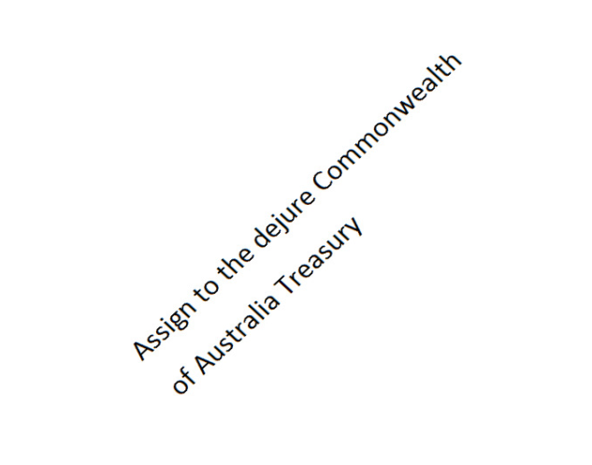

1. Then place **any value stamp in the bottom right hand corner on the back of the page** and **write the current date starting on the page but also continuing over the top of the stamp, with your signature likewise starting on the page but also continuing over the top of the stamp**.
2. Then **write these words underneath the dated and signed over sta**mp: **Without recourse.**

